North East University Bangladesh

Department of Computer Science and Engineering



**ALUMNI ASSOCIATION NEUB**

**By**

**Ishrat Jahan Tisha**

170103020102

**Bilasi Debnath**

160103020029

Department of Computer Science and Engineering

**Supervised By**

**Buddha Chandra Banik**

Lecturer

Department of Computer Science and Engineering

**Date: 25th June, 2020**

**Recommendation Letter from Project Supervisor**

The student’s*,* **Ishrat Jahan Tisha, Bilasi Debnath**whose project entitled**“ALUMNI ASSOCIATION NEUB”,** is under my supervision and I agree to submit for examination.

Signature of the Supervisor ：

Buddha Chandra Banik

Lecturer

Department of Computer Science and Engineering

North East University Bangladesh.

# Abstract

A common concern in institutions of higher education is to keep its former students involved with academic activities.

It is an agreement that one of the most valuable assets of universities is their alumni, given that their accomplishments ensure more exposure for the university. In recent years, universities have encouraged a movement toward the establishment of alumni associations, as they provide networking opportunities and contact between the university and the alumni or among the alumni.

An association that seeks membership and participation of its alumni should invest in the development of an attractive way.

In this sense, the project is aimed at analyzing a new system for alumni association mainly designed for North East University Bangladesh which is easy, fast, and efficient communication system. The system is a web based application that can be accessed throughout the World which manages information about the university and the students, gone together with technology.

**TABLE OF CONTENTS**

**Chapter 1**

1.1 Introduction 6

1.2 Background Information 6

1.3 Goal of These Project 7

**Chapter 2**

**Background Study**

2.1 Statement of the problem 8

**Chapter 3**

**Feasibility Study**

3.1 User and Admin Feasibility 9

3.2 Developer’s Site Feasibility 9

**Chapter 4**

**Requirement Analysis**

4.1 Requirements of the system 11

4.1.1 Functional Requirements 11

4.1.2 Non-Functional Requirements 11

4.2 Functionalities 12

**Chapter 5**

**ERD Diagram**

ERD Diagram 13

**Chapter 6**

**Graphical User Interface**

6.1 Home 14

6.2 Login(Admin and User) 15

6.3 Registration Form 16

6.4 About us 17

6.5 Gallery 18

6.6 Committee List 18

6.7 Member List 19

6.8 Event Page 19

6.9 Job corner 20

6.10 Career Page 21

6.11 Contact Page 22

6.12 User Profile 22

6.13 Create Event for current User 23

6.14 Create Job Circular for Current User 23

6.15 Create Career Blog Page For current User 24

6.16 Manage Event for Current User 24

6.17 Manage Job Circular for Current User 25

6.18 Manage Career Blog for Current User 25

6.19 Admin Dashboard Page 26

6.20 Admin Register Page 26

6.21 Member Registration Approval System Page 27

6.22 Admin Panel Registered Members List 27

6.23 Create Career Blog by Admin 28

6.24 Manage Career Blog by Admin 28

6.25 Update Career Blog by Admin 29

6.26 Update Image for Career Blog by Admin 29

6.27 Create Event Page by Admin 30

6.28 Manage Event by Admin 30

6.29 Update Event by Admin 31

6.30 Update Image for Event by Admin 31

6.31 Create Job Circular by Admin 32

6.32 Manage Job Circular By Admin 32

6.33 Update Job Circular by Admin 33

6.34 Update Image Job Circular by Admin 33

6.35 Manage Contact by Admin 34

**Chapter 7**

Tools used 35

**Chapter 8**

Conclusion 36

**Reference** 36

**ACKNOWLEDGEMENT**

# 

Thank you Allah,

Secondly we wish to extend our sincere appreciation to Buddha Chandra Banik sir for his continuous supervision, guidance, advice and constructive ideas throughout our work and making this partial project to be successful. We hope his cooperation will proceed till the end of the project. At the last, but not least, even if it is unusual, special gratitude for the group member participates with a great role with each other. Without the contribution of the group, our work would not be successful.

**Chapter 1**

**INTRODUCTION**

## Introduction

The greatest asset any Institution can have is the Alumni system. Alumni are the people who represent the Institution in the real world. Alumni website is created for the students that have graduated from the Institution. This is a web based application that allows former students to take advantage of the benefits and services that a Institution offers after graduation. The alumni network is becoming important in the development of the institution because of their vast potential that benefits both the Institution and the students. There are many benefits for being an alumni member of a college or Institution, some of these benefits are: keeping a person inform on the events that are organized by the Institution, and when some important events will be holding in the Institution. Another benefit is that information concerning a former student can easily be received and other members of the alumni community can be located without much stress. The student and alumni can communicate each other.

## 1.2 Background Information

Alumni are one of the most important assets to any university. They are the people who represent the university in the real world. Many alumni network initially started from regional groups of alumni brought together for university fundraising activities. Later, these networks slowly gained added importance in the development of the university because of their enormous outreach potential that benefits the university and helps other societies in their career paths.

Alumni association has been in existence for decades and they are constantly changing with time. There have been very big changes in the recent years with the development of the internet and social networking that forces the alumni system to undergo huge changes. Therefore, it is really important for universities to focus on the alumni networks and find ways to enhance their growth and development.

The system called “ALUMNI ASSOCIATION NEUB” proposed in this ideas offers an inter mix of traditional alumni systems and social networking sites. The brief study on both systems is undertaken and important features of these systems are incorporated into the new proposed system.

Why Social networking? This can be described as the act of social relationships for the purpose of common needs, interests or goals. Networking has been taking place all over the world since the existence of humans. Nowadays networking has become easy because of the development of technology. People can interact with one another and share their ideas, discuss their personal and professional lives without even moving from their desks. The existing systems are usually developed to facilitate networking between the alumni and their respective universities, but most of these current systems are not being used by the majority of the alumni.

* 1. **Goal of This Project**

The main goal of the project is to provide a user friendly website so that the information about event and program, career, job corner, member list, payment system, user details, committee list details are properly handle with the website.

**Chapter 2**

**BACKGROUND STUDY**

**Overview**

We have analyzed some of the websites for our background study such like various Alumni Association CSE, Alumni Association etc. to get idea for designing our interface, E-R diagram, database designing and user functionalities.

**2.1 Statement of the problem**

This type of website is currently used by many universities but in our university there have no such website.

**Chapter 3**

**FEASIBILITY STUDY**

**The feasibility study is divided into two sites:**

1. User and admin feasibility
2. Developer site feasibility
   1. **User and admin feasibility**

* **Technical Feasibility**

To use the system users need a personal computer with the following hardware like – Processor: Intel Dual Core (or above)

RAM: 512 MB (min)

Hard Disk: 30 GB (or above), Or A mobile phone with latest browser.

* **Financial Feasibility**

For this system some amounts will be spend like –Internet Bills

The system will follow freeware software standards. No costs will be charge from the potential users.

* **Resource Feasibility**

Resource that is required for the system –Laptop / Desktop / Mobile Phone

Active Internet Connections.

* **Risk Feasibility**

Users will get all facilities which are needed for this system.

They will get all the requirements to use this system.

**3.2 Developer’s Site Feasibility**

* **Technical Feasibility**

The system will be established by HTML, CSS, Bootstrap, JavaScript, and JQuery in frontend and PHP, MySQL Server in the backend.

The hardware needs-

* Processor : Intel Dual core(or Above)
* RAM: 2GB
* Hard Disk : 30 GB (or Above)

So, the project is technically feasible.

* **Financial Feasibility**

This assessment typically involves a cost analysis.

For this project some amount will spent like-

* Internet bills.
* Arrange meetings with society members & teachers etc.

So, the project is financially feasible.

* **Resource Feasibility**

Resources that are needed like-

* Laptop/Desktop
* Hosting space
* **Risk feasibility**
* The tools which are needed to develop the project are all available and free source to use.
* The project is being a 8 month project. We have divided our work into several sections and hopefully we will complete the project in time and deliver.

**Chapter 4**

**REQUIREMENT ANALYSIS**

**We have done our Requirement Analysis part with the following steps:**

* Talked with teacher of department of CSE and alumnus for collect data.
* Interviewed with the developer of similar systems.
* Visited similar existing websites.
* Analyzed those data to find different types of requirements.

**4.1 Requirements of the system**

The requirements of the system divided into two types:

1. Functional Requirements

2. Non – Functional Requirements

* + 1. **Functional Requirements**

There are two types of functional requirement –

* Normal Functional Requirements
* Expected Functional Requirements
* **Normal Functional Requirements**
* The system should require information about its Users.
* Store the information's of Users in database.
* Store the information's of posts in database.
* A Super Admin will verify a new registered user.
* System should also require the functionalities like User registration, Profile, Update profile, create an event, search etc.
* **Expected Functional Requirements**
  + Mobile responsive.
    1. **Non-Functional Requirements**

**The system is able to perform the following characteristics-**

* **Usability:** The system can be operate from any kind of Operating System.
* **Reliability:** The system is available on the user needs, can work properly. Every registered user account will be verified by email & admin and also password protected.
* **Performance:** The system will be optimized and can perform better in any web browser.
* **User interface:** The user interface will be user friendly which is easy to use.
* **Storage Backup:** There will be a storage backup for the system so that the information of users and posts data’s can’t be loss.
  1. **FUNCTIONALITIES**

Based on our requirement, we decided some functionalities for different type of users.There are three types of authorized user, they are Committee members, members and Super Admin (The president of ALUMNI ASSOCIATION NEUB).

* **Committee Members:**

1. Can create an account.
2. Can add/remove members.
3. Can manage events completely.
4. Can create job posts.
5. Can create career guidance posts.

* **Members:**

1. Can create an account.
2. Can create post in career.
3. Can create post in job corner.
4. Can see all job circular.
5. Can see all events.
6. Can see committee members.
7. Can see other members.
8. Can update or delete career post
9. Can update or delete job post
10. Can see his/her profile
11. Update Information of his/her profile

* **Super Admin:**

1. Can view all users.
2. Approve registered members.
3. Can add/remove members.
4. Can add/remove alumnus..
5. Can collect membership fee from alumnus.
6. Can manage events completely.
7. Can create, delete and update job posts.
8. Can create, delete and update career posts.

# Chapter 5

# ERD DIAGRAM

**Overview**In this chapter we will discuss about our ER Diagram.

**ERD diagram**

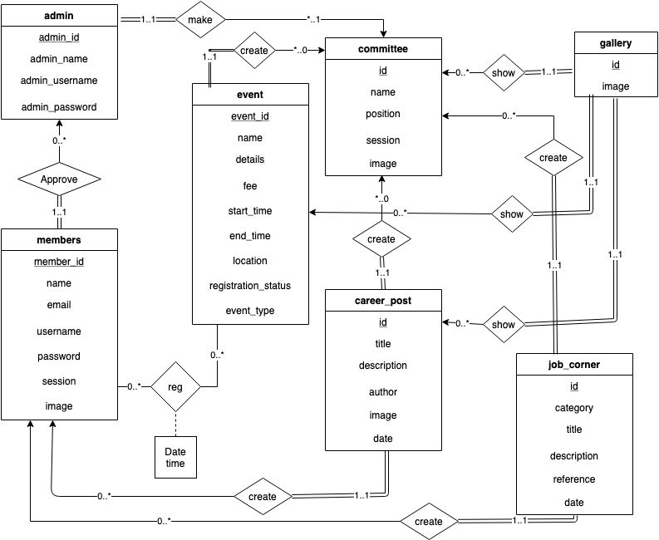

**Fig: ERD Diagram With UML Notation**

# Chapter 6

# GRAPHICAL USER INTERFACE

**Overview**

In this chapter we will discuss about the User Interfaces of this websites.

**6.1 Home**

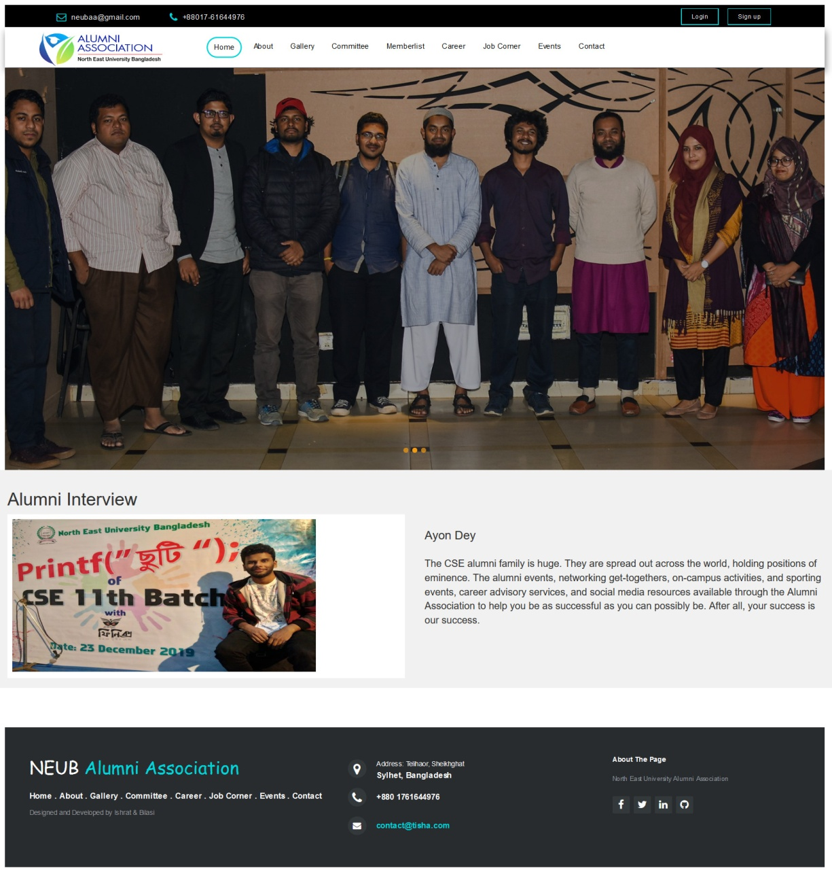

**Figure: Home Menu**

This is the home page menu bar that is the very first page where user can access all other pages to see the about, gallery, committee, career, job corner, contact us and others.

**6.2 Login (admin and users)**

**Admin login**

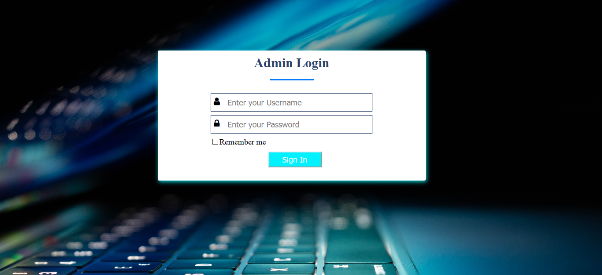

**Figure: Admin Login page**

In this page admin can login with their username and password.

**User login**

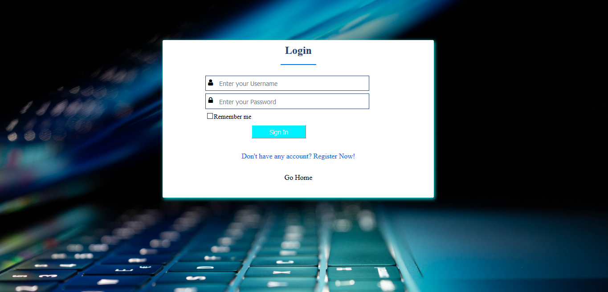

**Figure: Login page**

In this page members can login with their username and password

**6.3 Registration form**

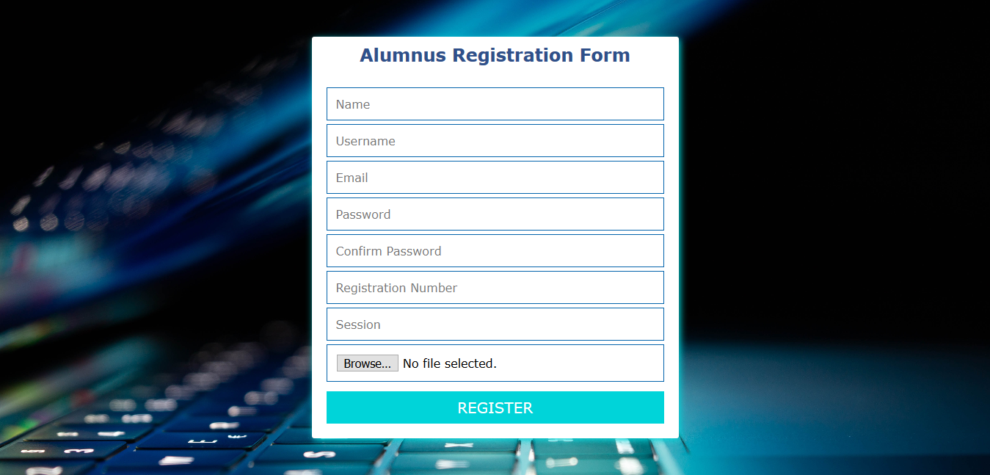

**Fig: registration form (step:1)**

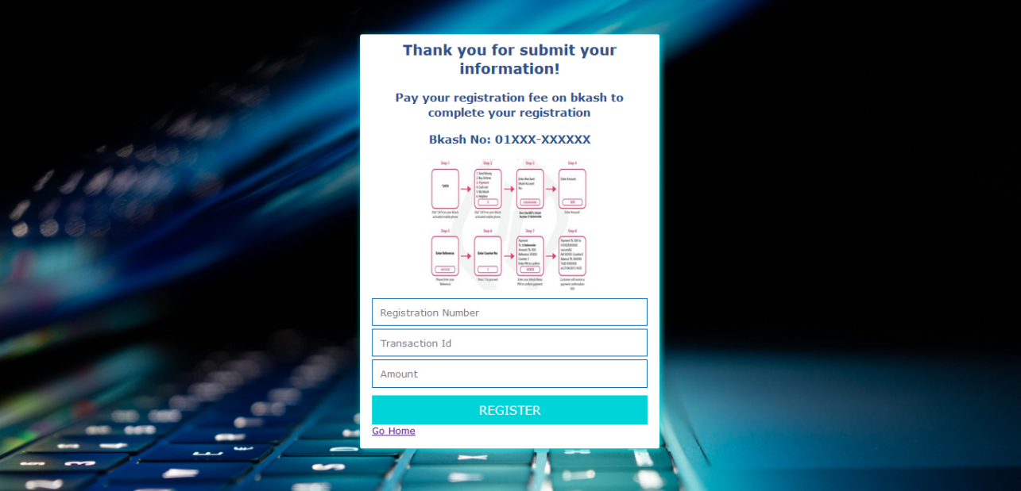

**Fig: registration form (step:2)**

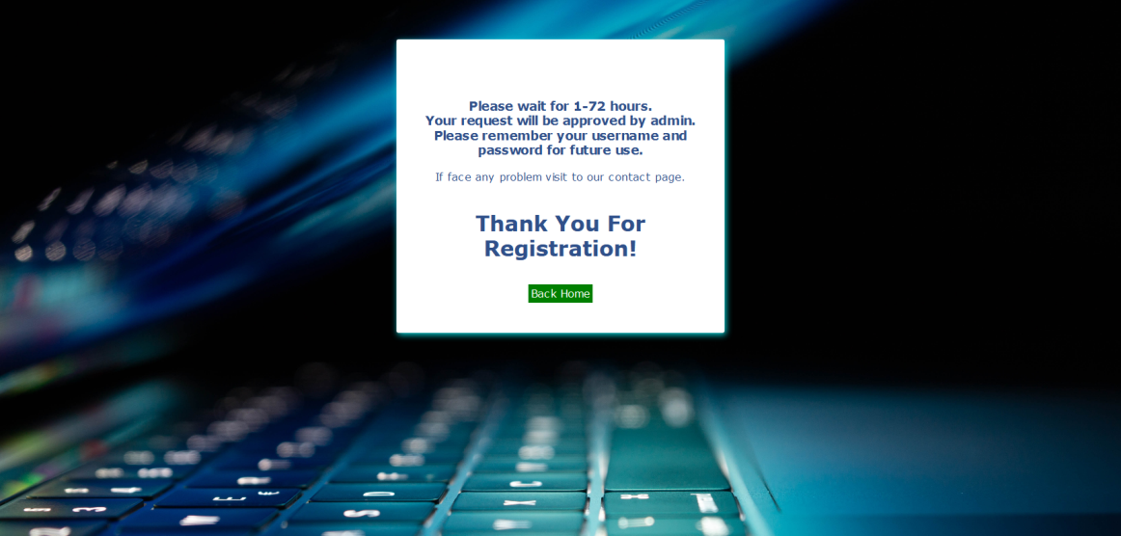

**Fig: registration form**

If any alumnus student wants to register as a member he/she have to complete 2 step of this registration process and have to wait for admin approval.

**6.4 About us**

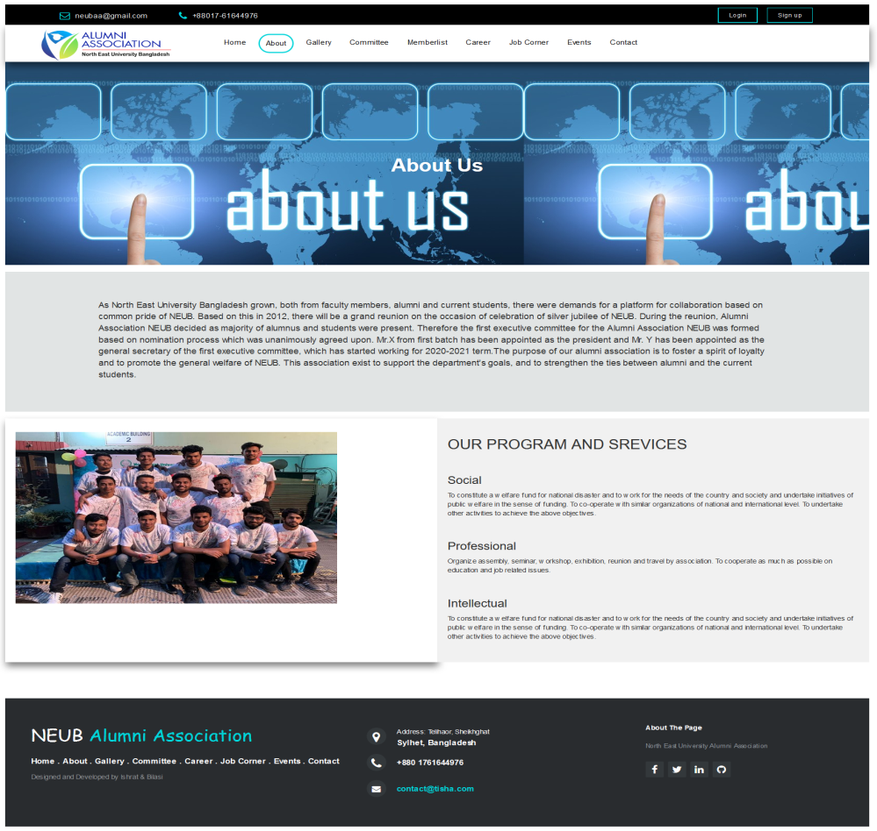

**Figure: About page**

There are all details about of Alumni Association North East University Bangladesh.

**6.5 Gallery**

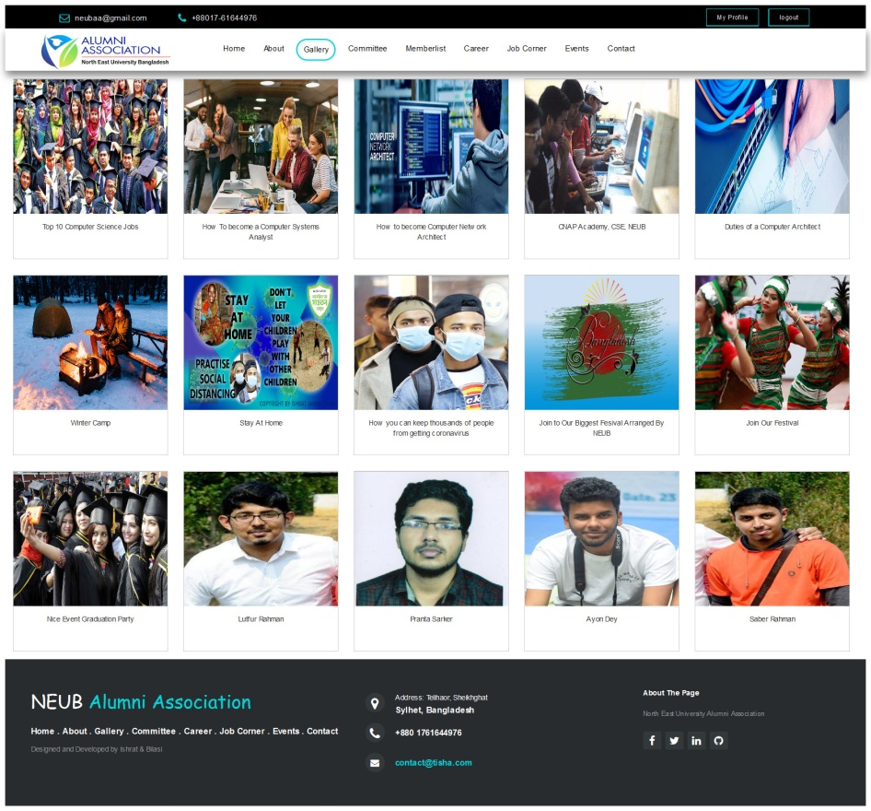

**Figure: Photo gallery**

This is gallery of all image are uploaded by members and admin.

**6.6 Committee List**

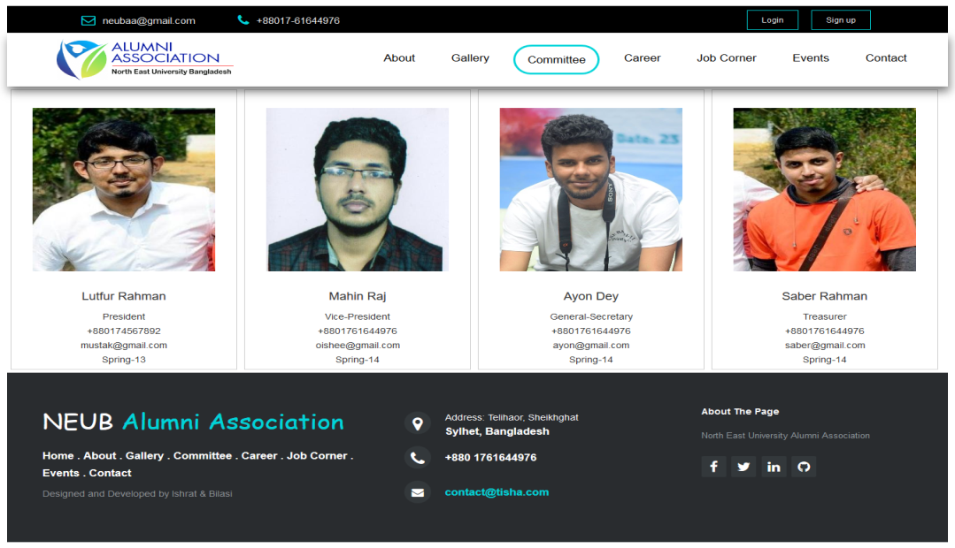

**Figure: Committee**

This page contains all committee members list.

**6.7 Member List**

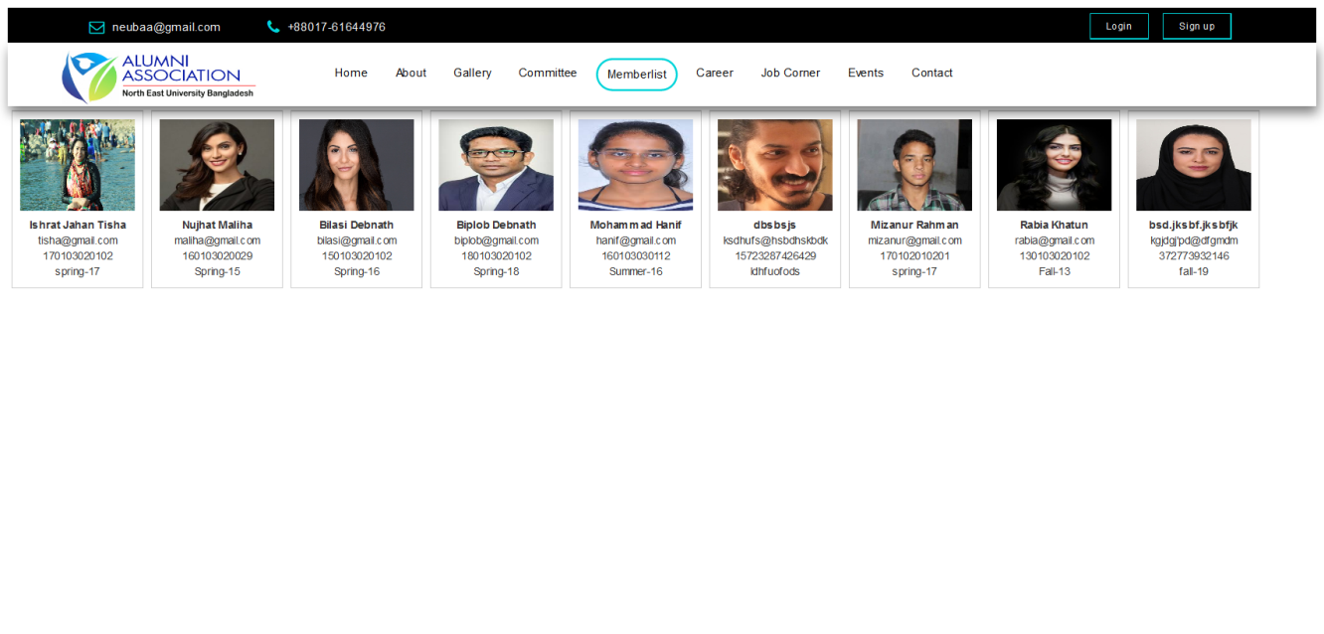

**Figure: Registered Members**

In this page everyone can see registered members list.

**6.8 Event page**

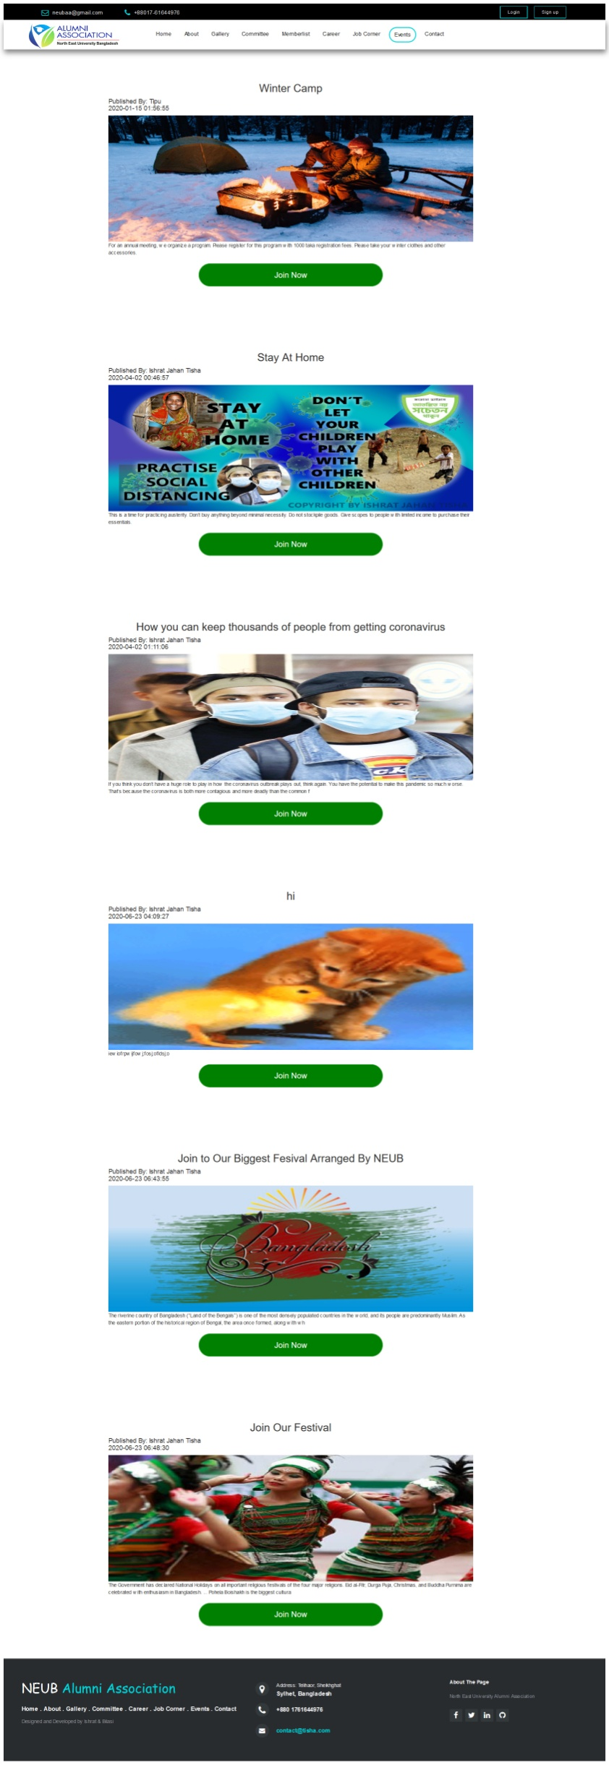

**Figure: Event and Programs**

This page contains all events of alumni association.

**6.9 Job Corner**

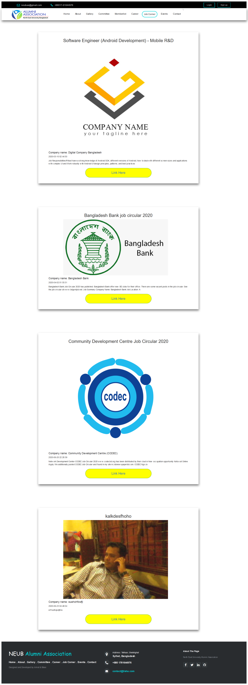

**Figure: Job Circulars on Job Corner Page**

This page contains all job circulars posted by admin and members.

**6.10 Career page**

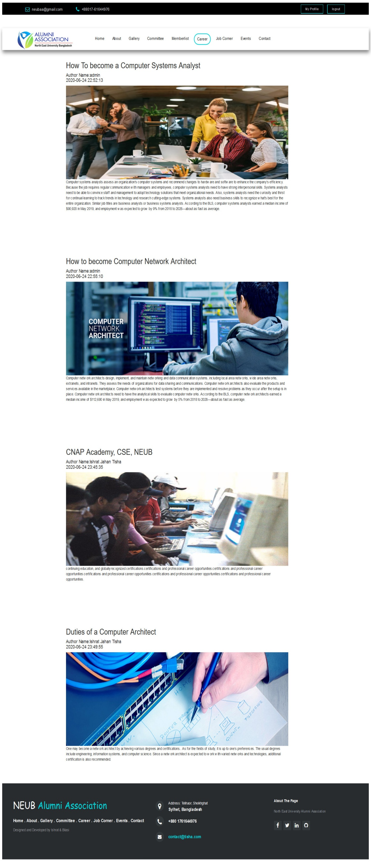

**Figure: Career page**

This page contains all career guidance post. This posts are all created by admin and members.

**6.11 Contact page**

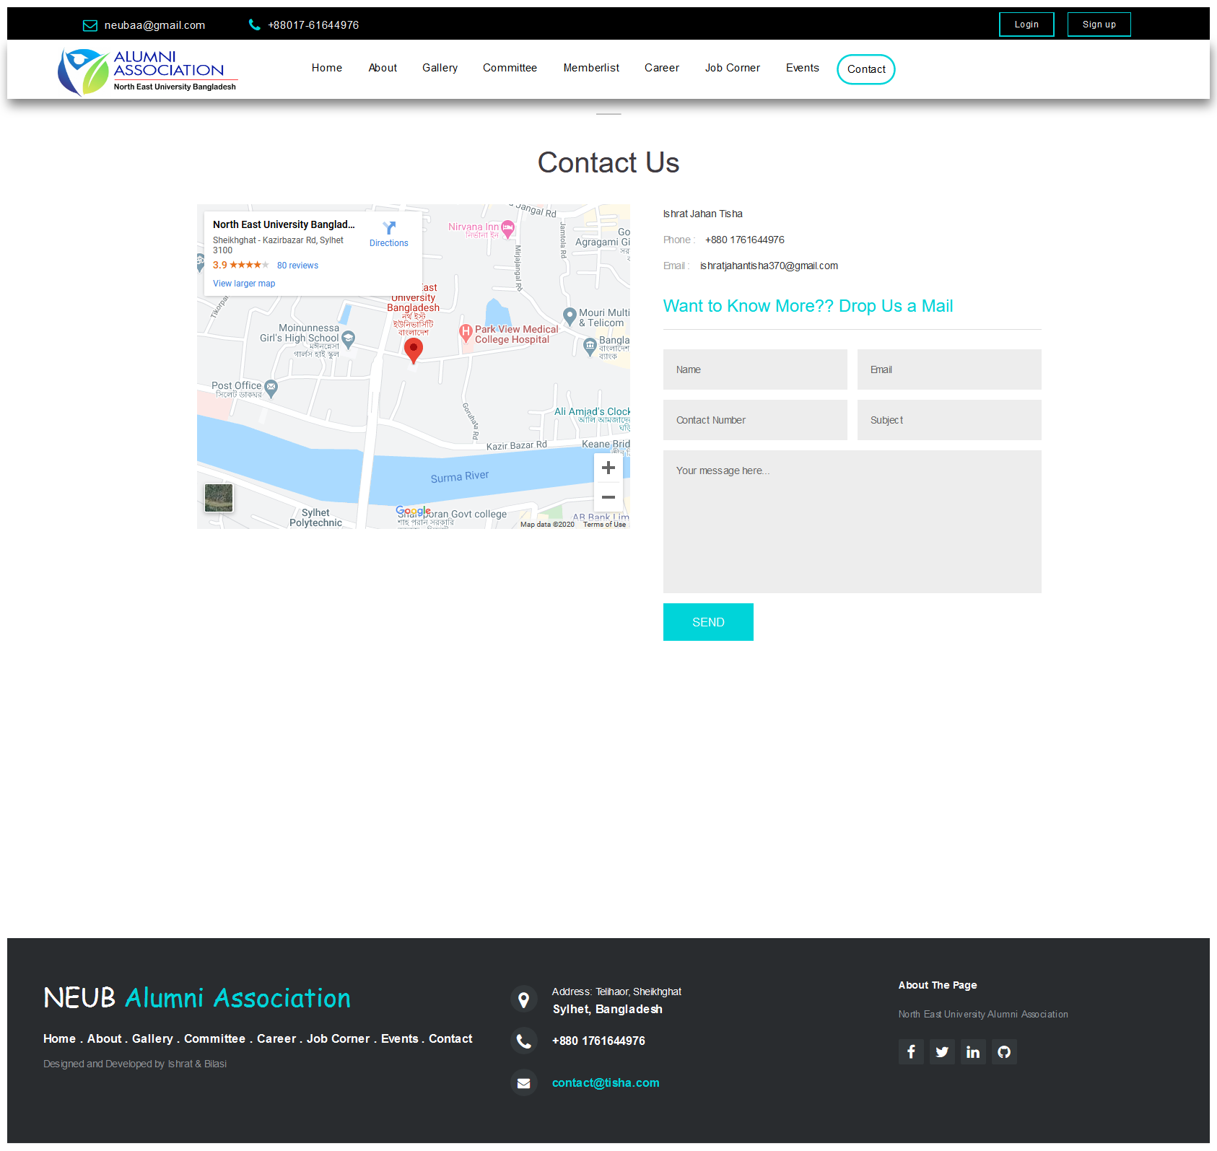

**Figure: Contact Page**

Members or outsiders can contact by contact page by sending message or call to the given number.

**6.12 User Profile**

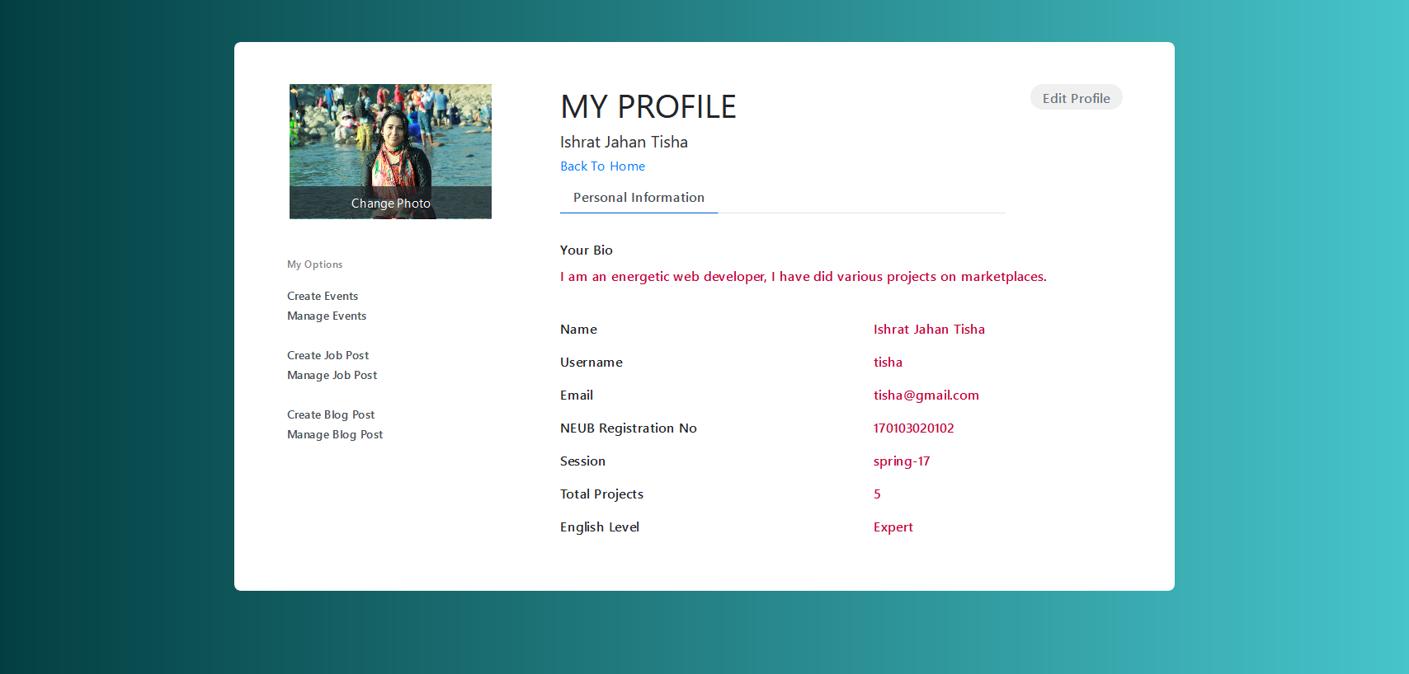

**Figure: User profile**

Current registered user can see his/her profile by click My Profile Button. Can see his/her all information and can use various options.

**6.13 Create Event for Current User**

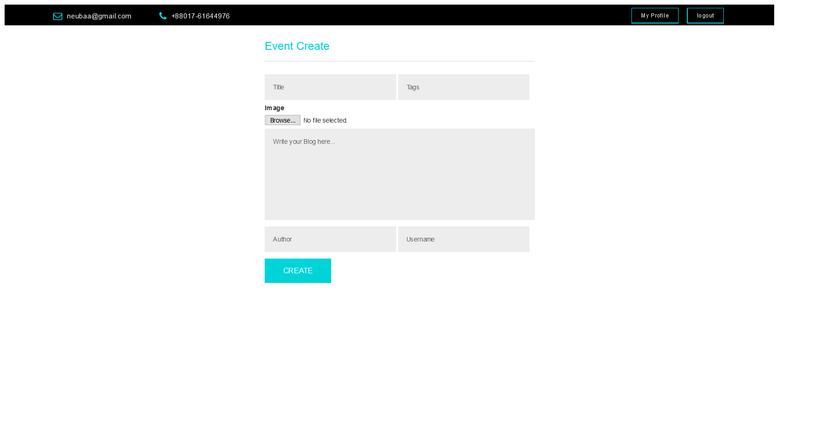

**Figure: Create Event Page for Current User**

Current user can create any event.

**6.14 Create Job Circular for Current User**

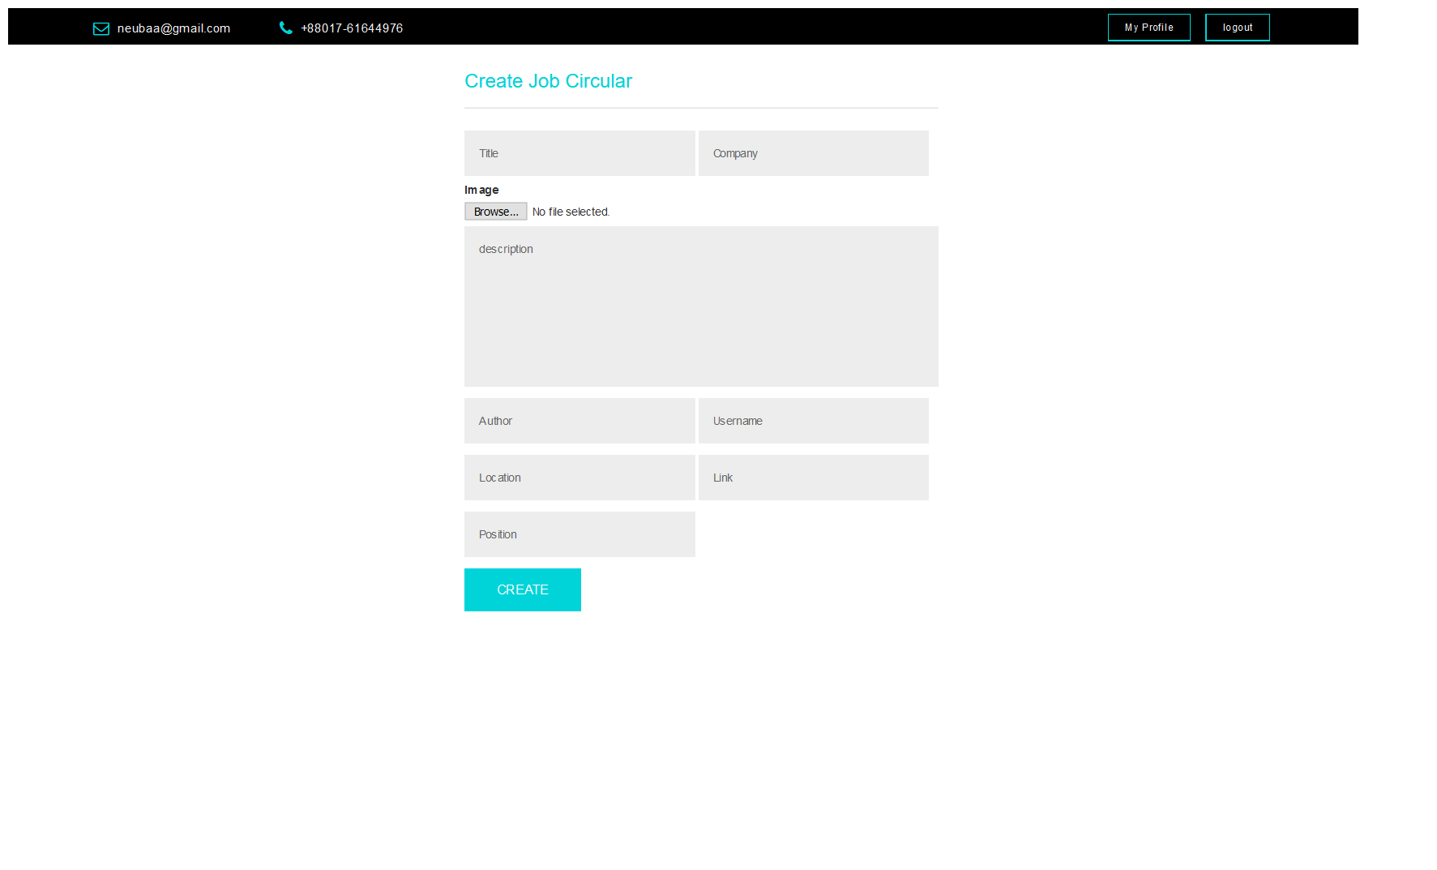

**Figure: Create Job Circular Page for Current User**

Current user can create any job circular with link.

**6.15 Create Career Blog Page for Current User**

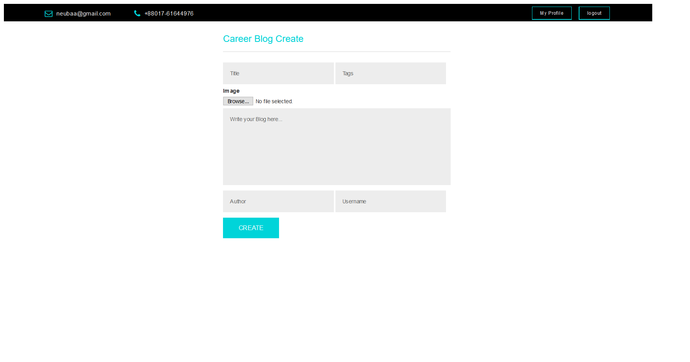

**Figure: Create Career Blog Page for Current User**

Current user can create any career guidance post.

**6.16 Manage Event for Current User**

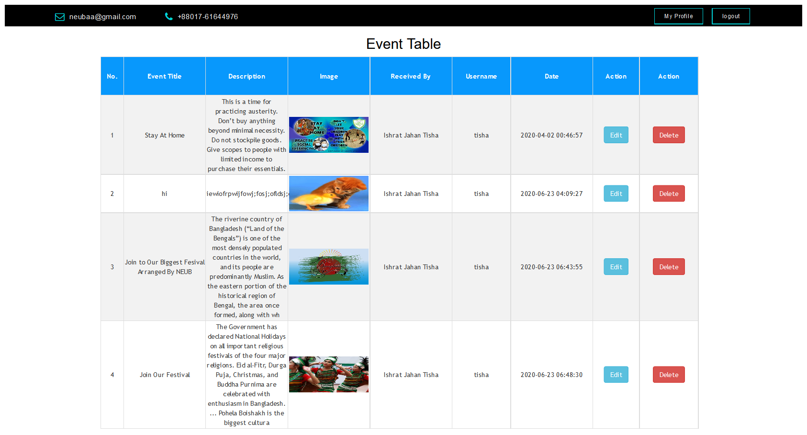

**Figure: Manage Event for Current User**

Current user can manage any event. Here he/she can only see, delete and update his/her posts.

**6.17 Manage Job Circular for Current User**

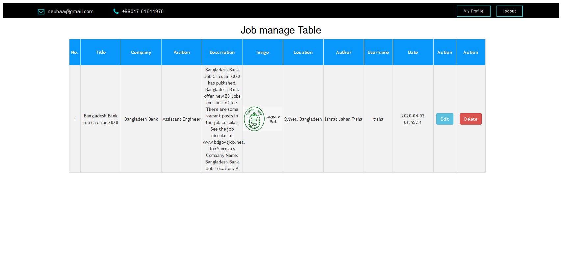

**Figure: Manage Event for Current User**

Current user can manage any job circular. Here he/she can only see, delete and update his/her posts.

**6.18 Manage Career Blog for Current User**

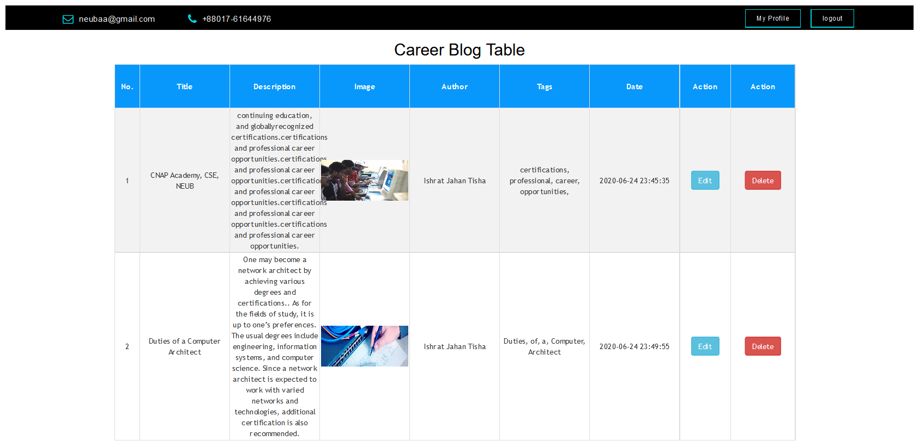

**Figure: Manage Career Blog for Current User**

Current user can manage any career blog post. Here he/she can only see, delete and update his/her posts.

**6.19 Admin Dashboard page**

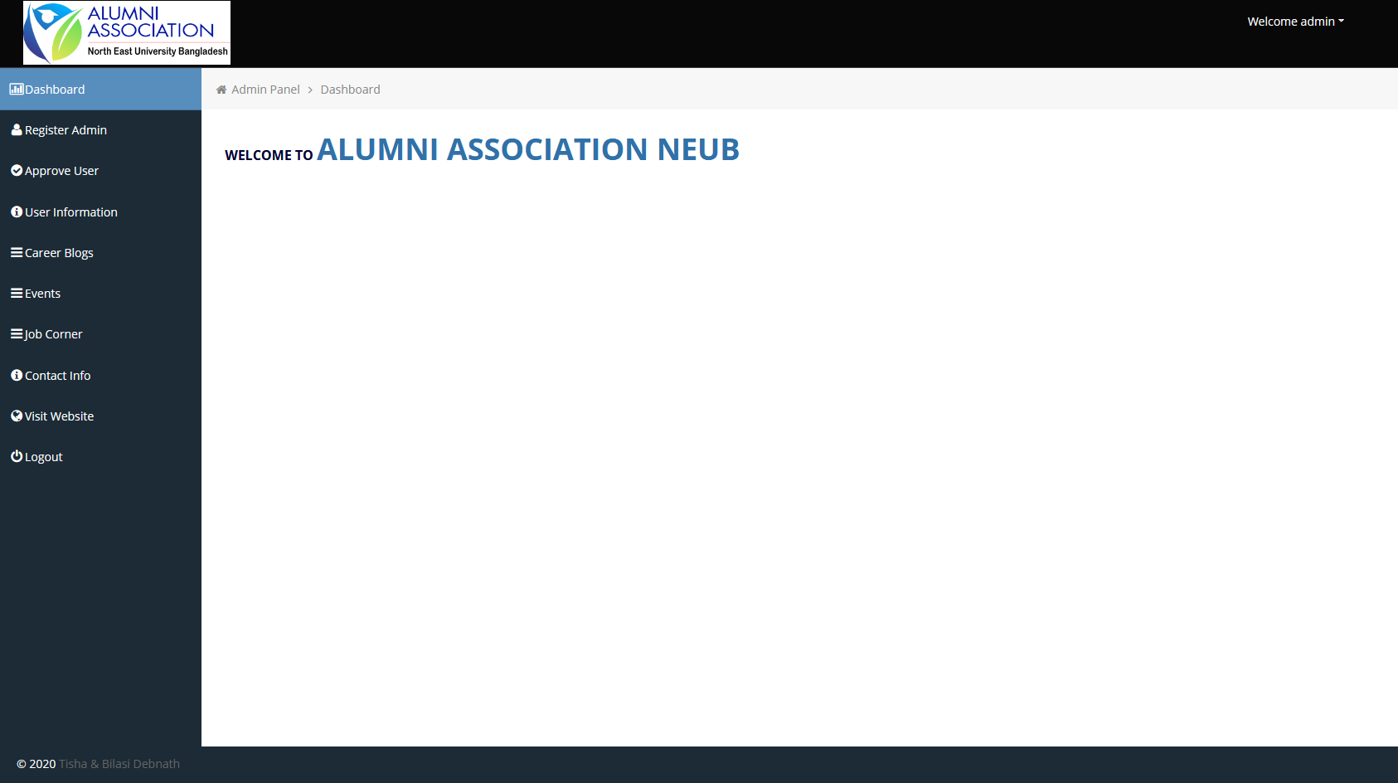

**Figure: Admin Dashboard Page**

After login as admin, this dashboard will be showed.

**6.20 Admin register page**

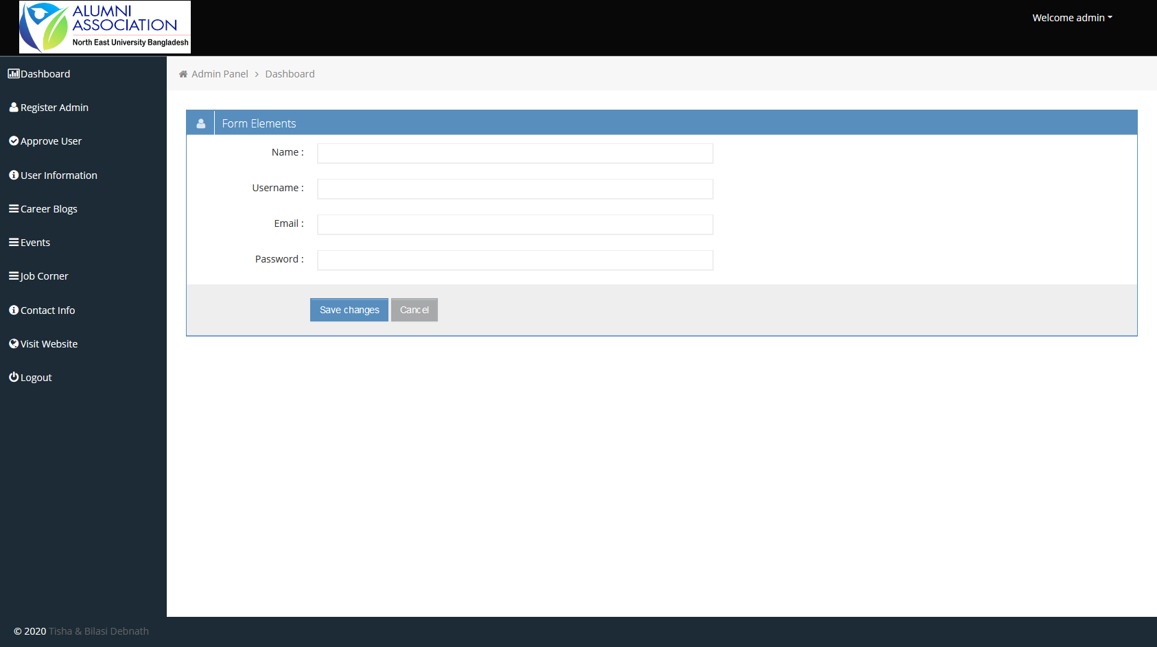

**Figure: Admin Register Page**

Admin can register other admin by this page.

**6.21 Member Registration Approval System Page by Admin**

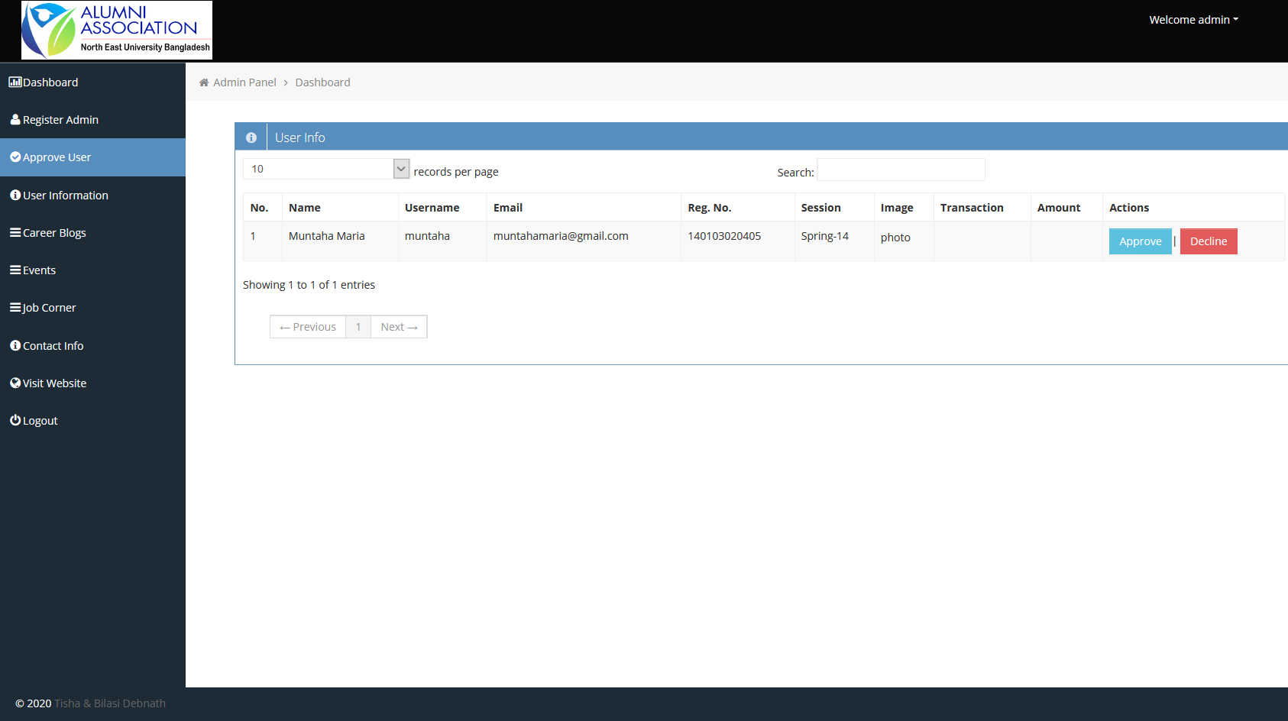

**Figure: Member Approval Page**

This is the approval page. If any alumnus student process his/her registration and complete transaction by Bkash paying fee. Enter Bkash transaction id successfully. The admin will be checking the phone, if matched; admin will approve him/her as a registered member.

**6.22 Admin panel registerd members list**

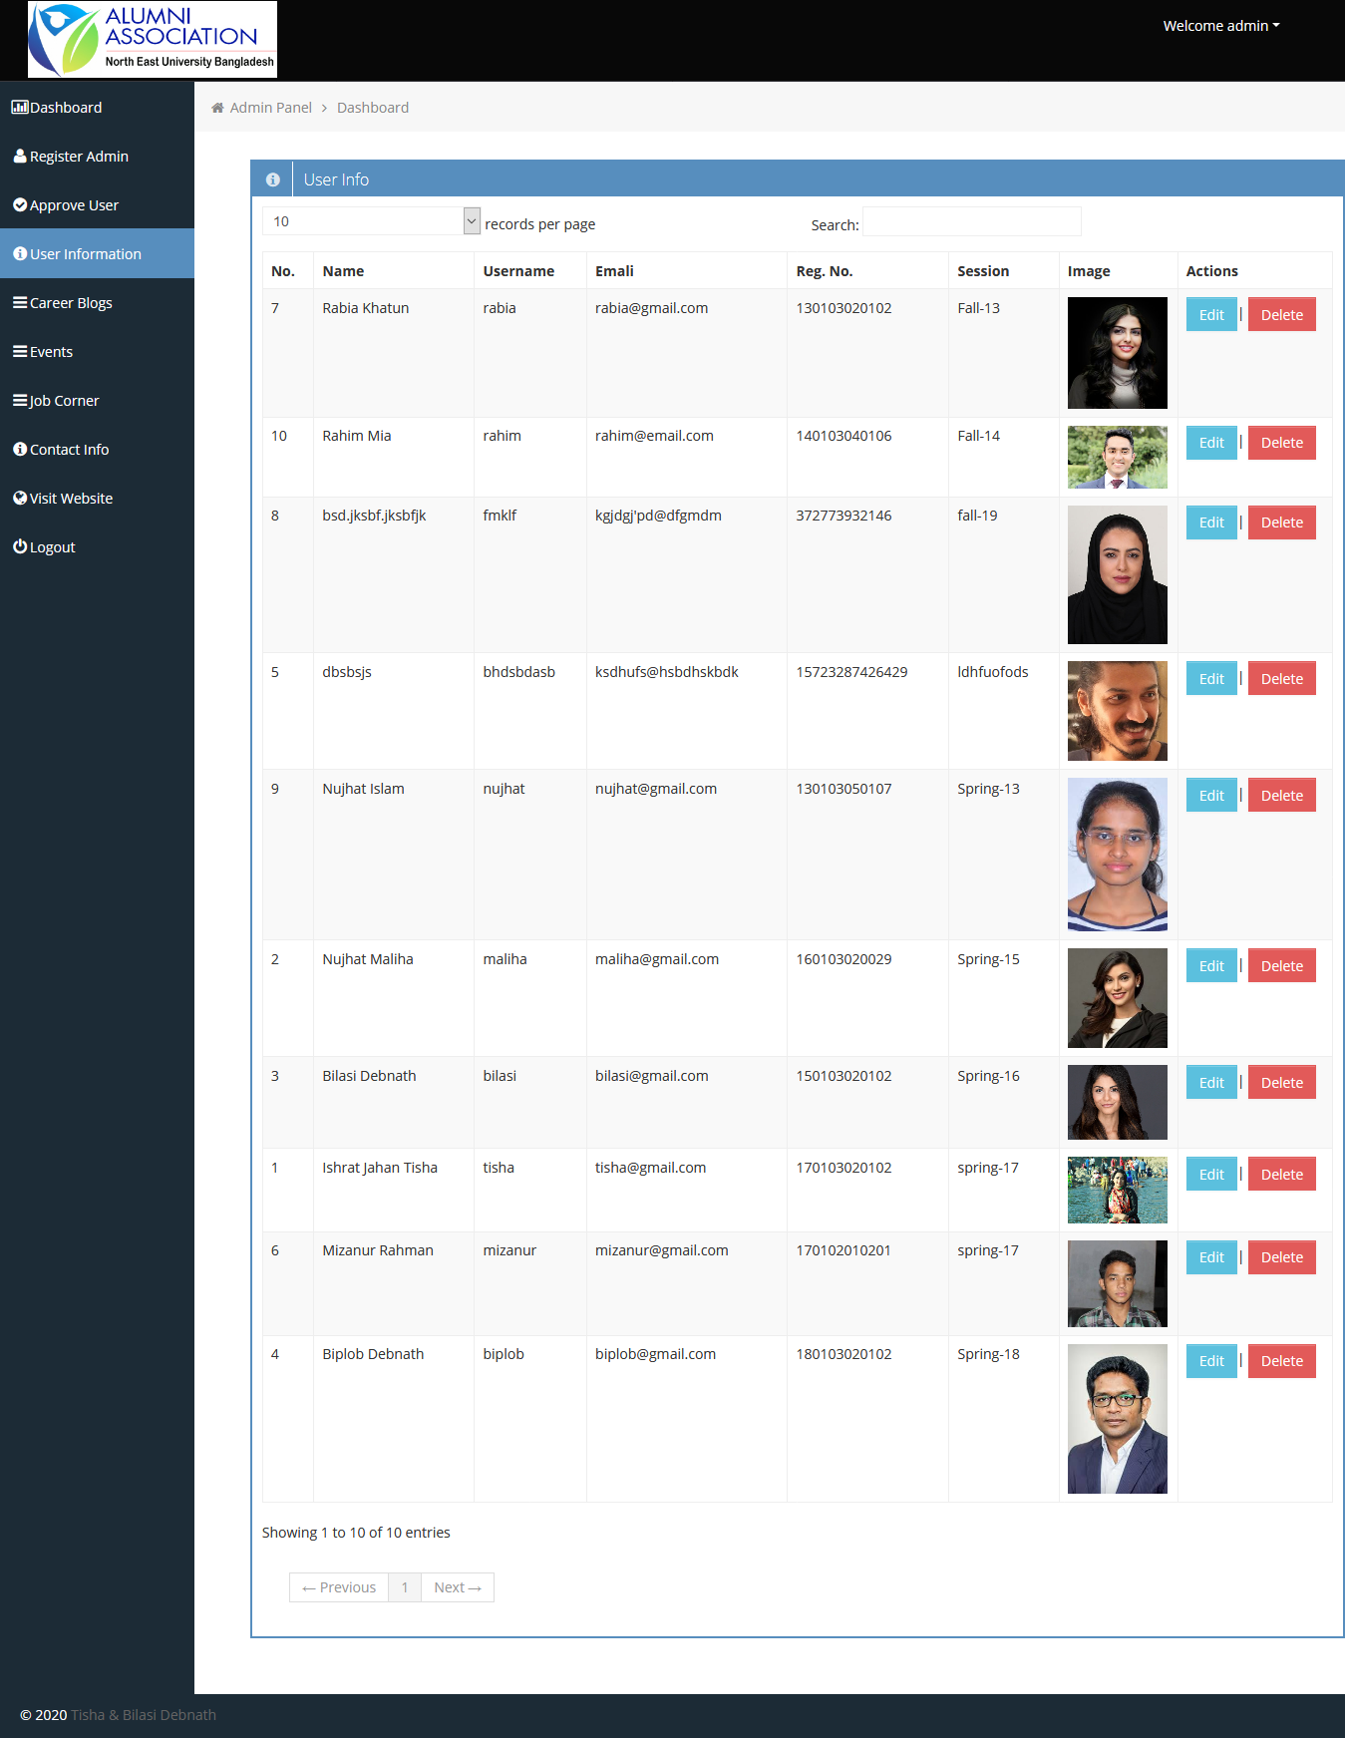

**Figure: Admin Panel Members List**

This page contains registered members list.

**6.23 Create Career Blog by Admin**

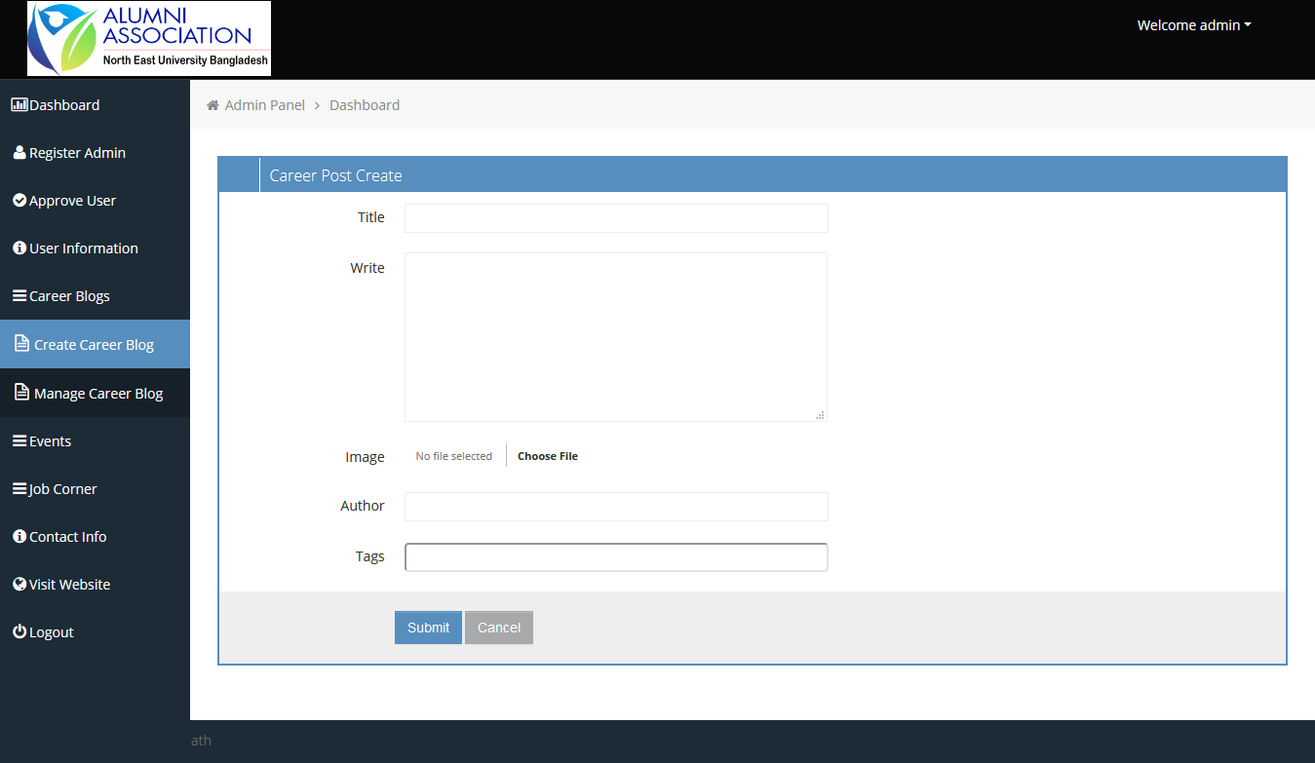

**Figure: Create Career Blog by Admin**

Admin can create career guidance related blog by this page.

**6.24 Manage Career Blog by Admin**

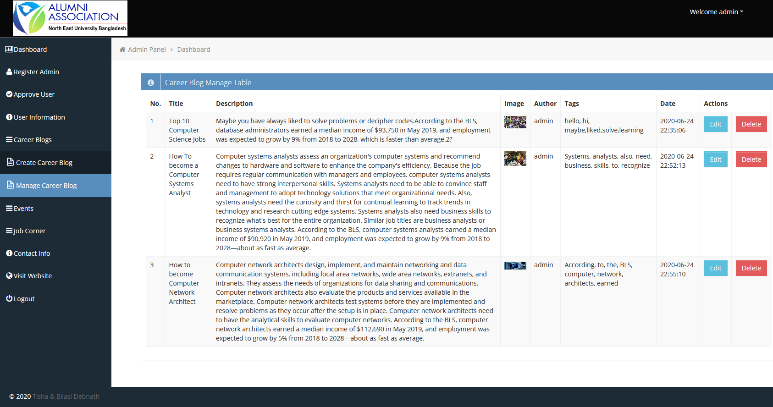

**Figure: Manage Career Blog by Admin**

Admin can view and manage career post by this page.

**6.25 Update Career Blog by Admin**

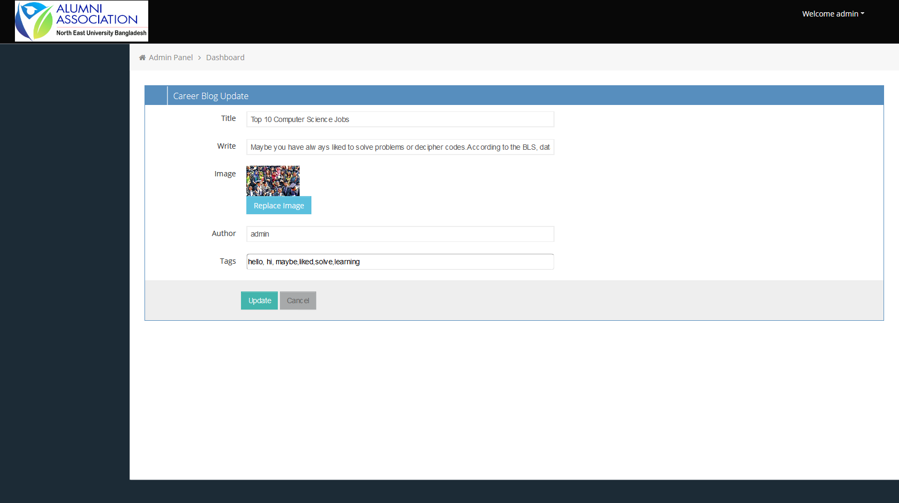

**Figure: Update Career Blog**

Update career blog from this page.

**6.26 Update Image for Career Blog by Admin**

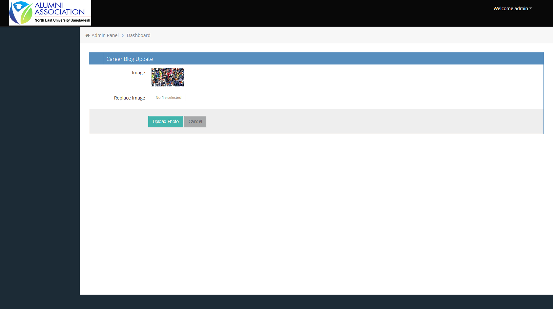

**Figure: Update Image on career blog by Admin**

Update Image for career blog image from this page.

**6.27 Create Event page by Admin**

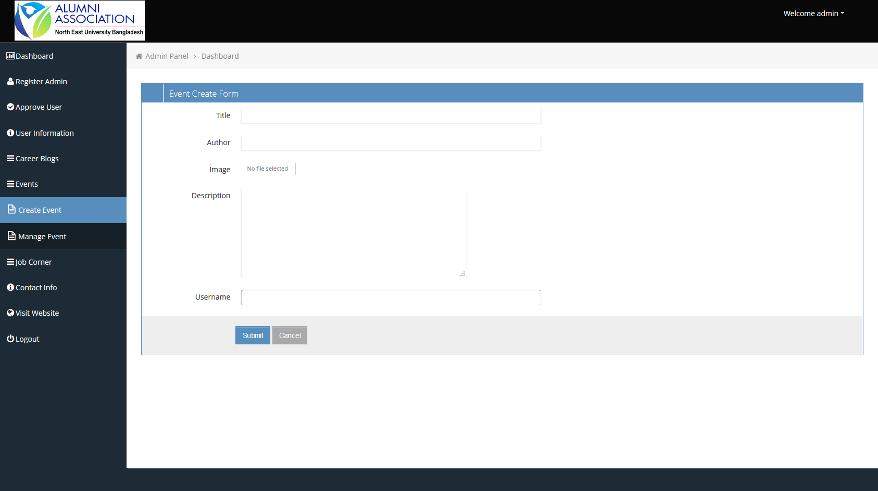

**Figure: Create Event page by Admin**

From this page admin can create event.

**6.28 Manage Event by Admin**

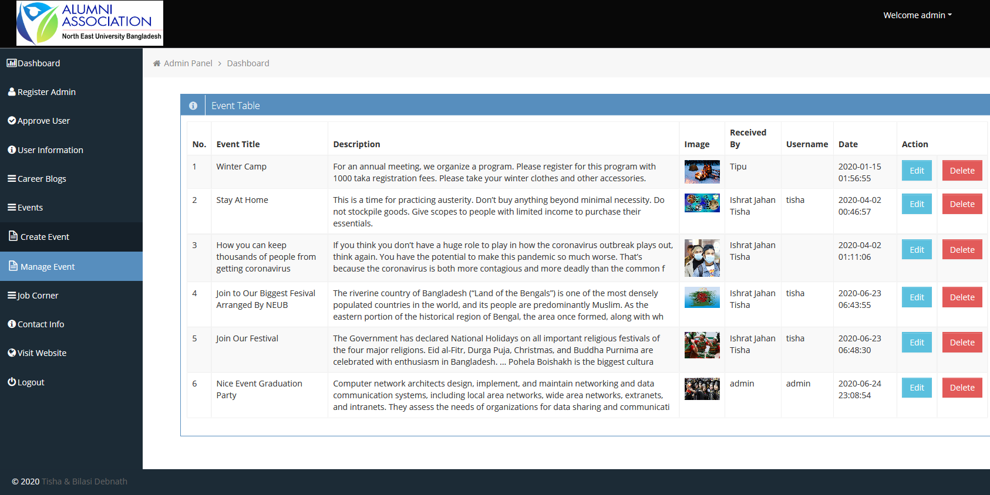

**Figure: Manage Event by Admin**

Admin can view and manage event by this page.

**6.29 Update Event by Admin**

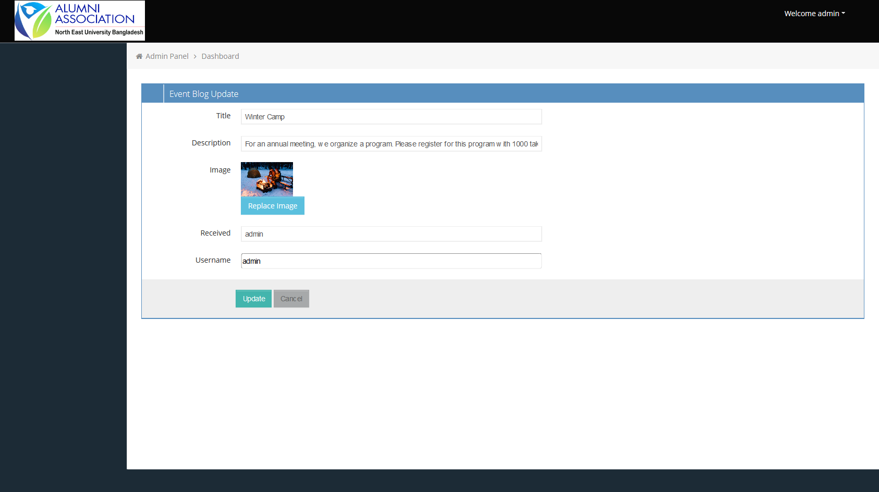

**Figure: Update Event by Admin**

Update event from this page.

**6.30 Update Image For Event by Admin**

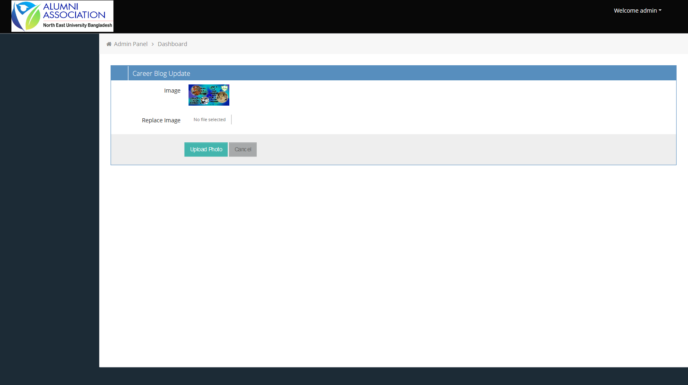

**Figure: Update Image for Event by Admin**

Update Image for event image from this page.

**6.31 Create Job Circular by Admin**

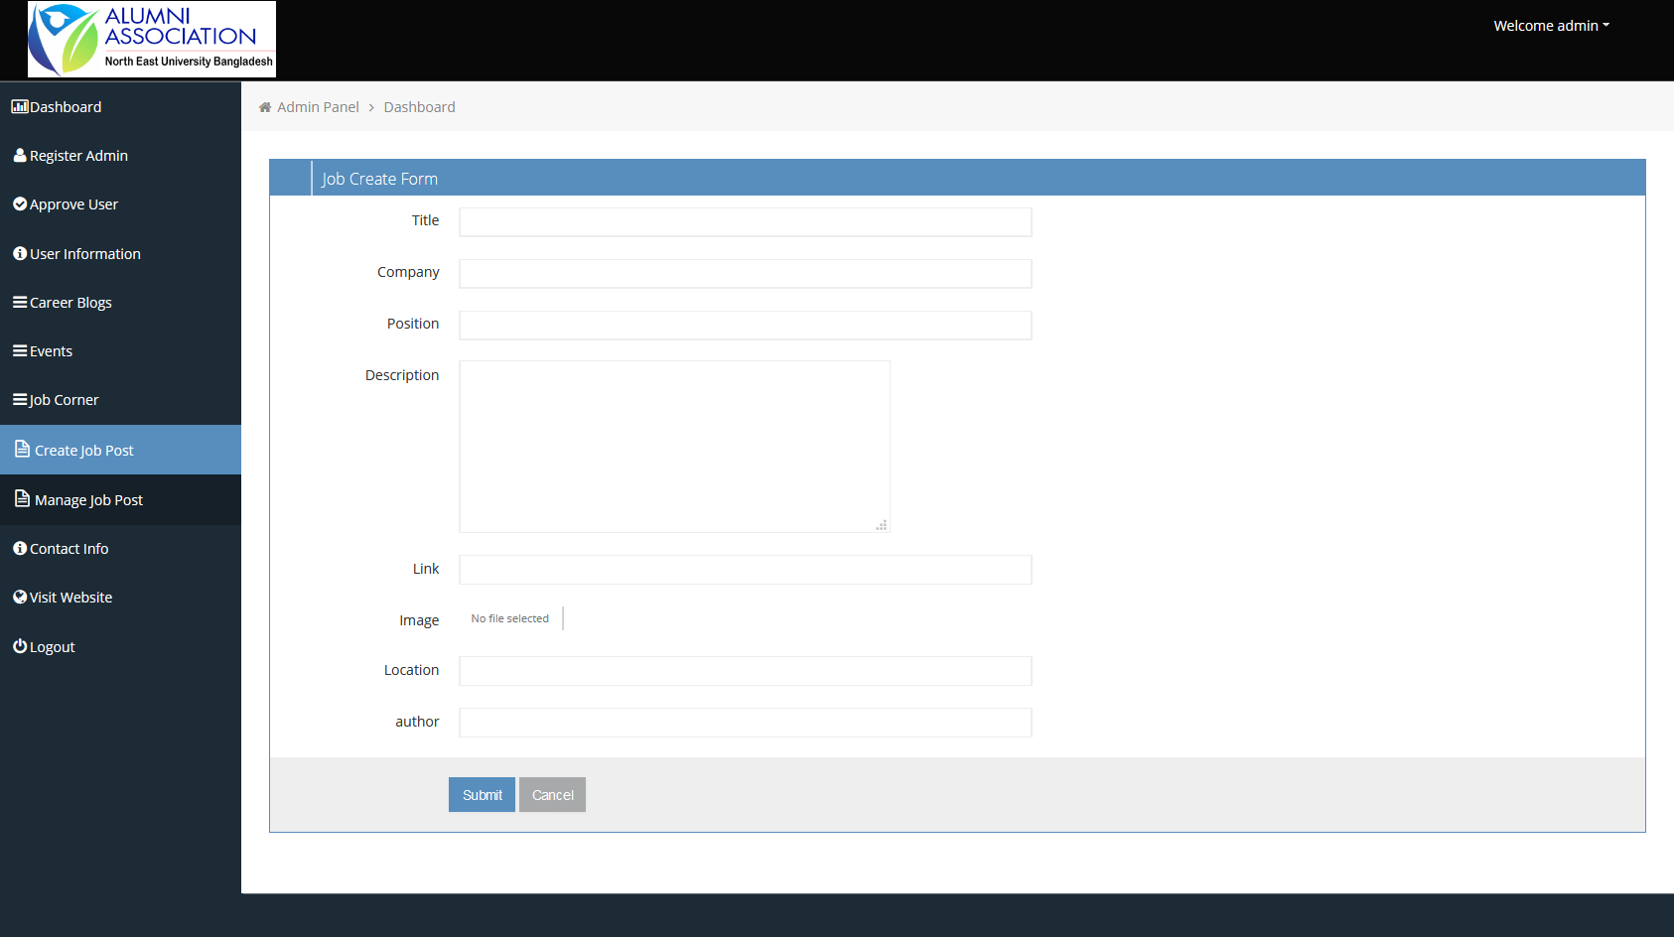

**Figure: Create Job Circular by Admin**

From this page admin can create job circular.

**6.32 Manage Job Circular by Admin**

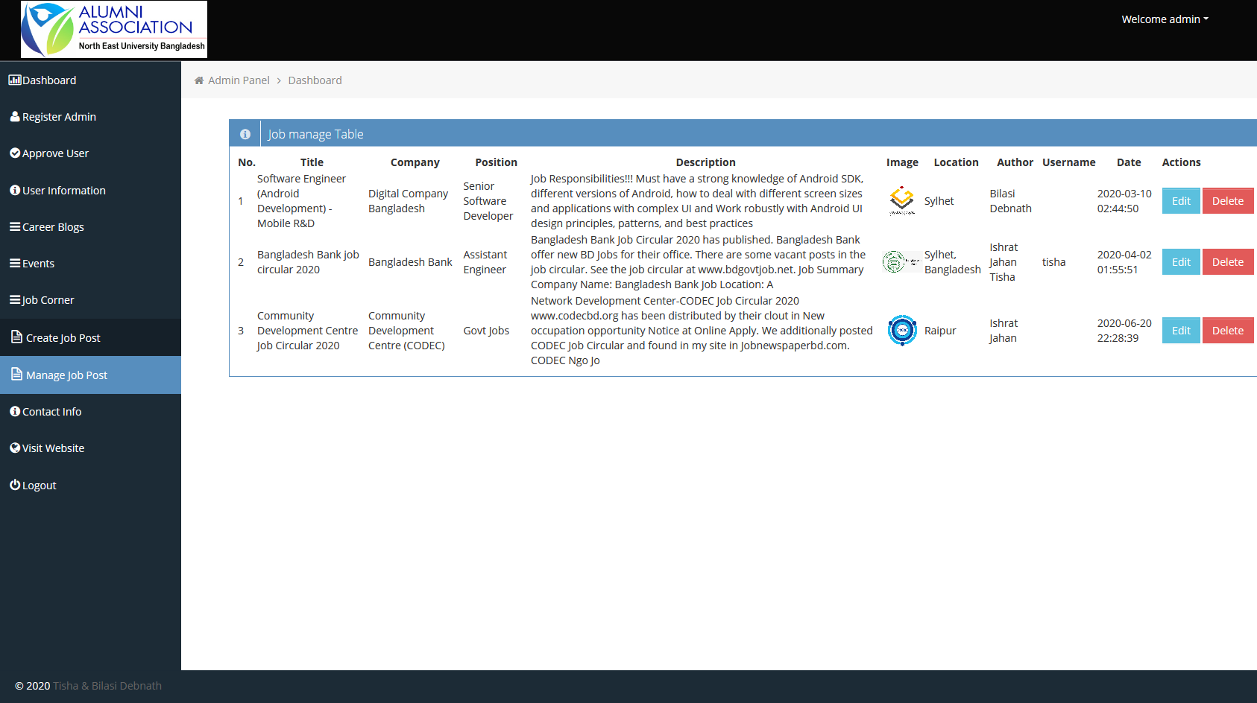

**Figure: Manage Job Circular by Admin**

Admin can view and manage job circular by this page.

**6.33 Update Job Circular by Admin**

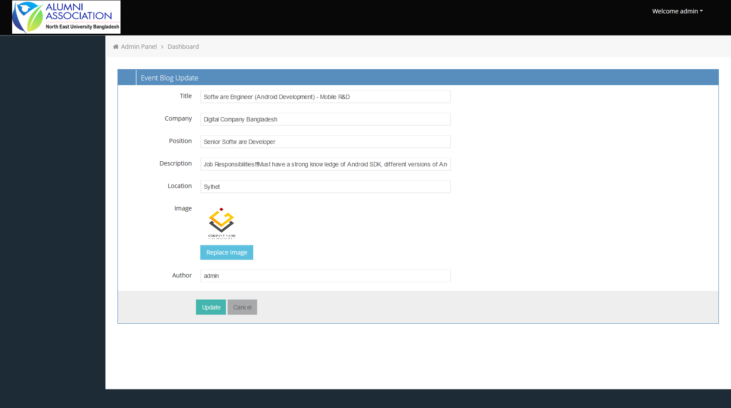

**Figure: Update Job Circular by Admin**

Update job circular from this page.

**6.34 Update Image Job Circular by Admin**

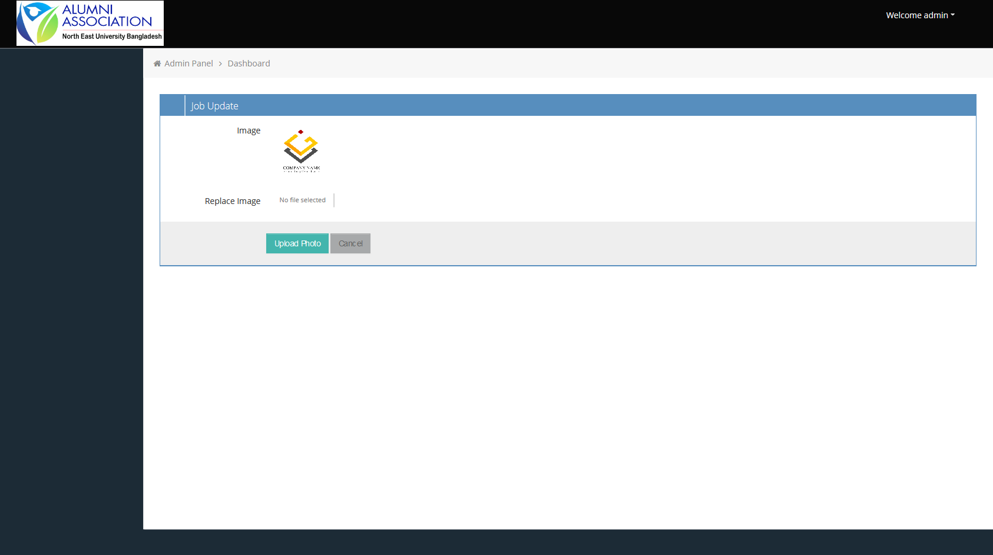

**Figure: Update Image Job Circular by Admin**

Update Image for event image from this page.

**6.35 Manage Contact by Admin**

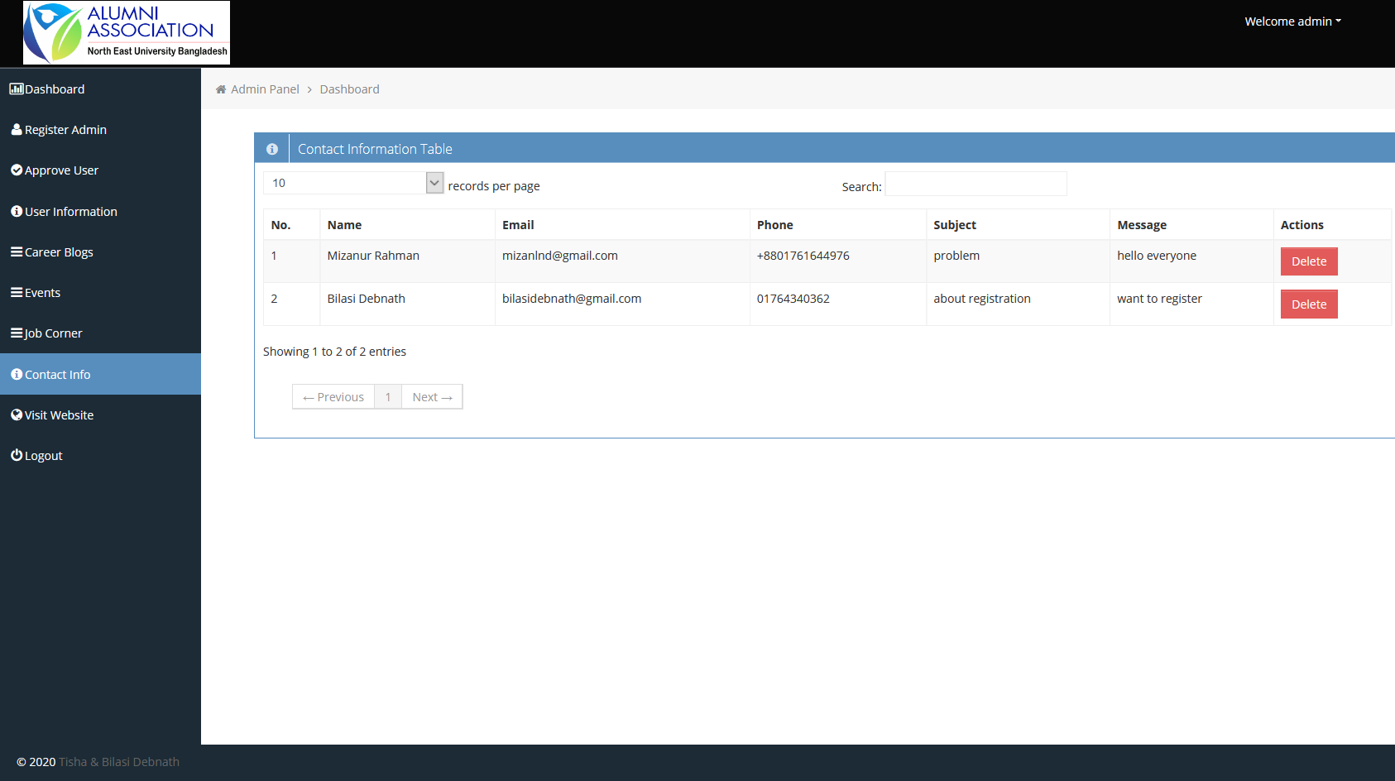

**Figure: Contact Page by Admin**

In this page admin can see messages which are received from members or outsiders.

# Chapter 7

# TOOLS USED

**Overview**

In this chapter we will discuss about the tools used to develop the Website.

## Tools used

* + - **HTML, CSS**

Basically HTML and CSS are mostly used for designing part that is called front end designing. Here we used html and CSS for our font end designing part. Html used for coding of design and CSS we used for make the pages attractive and user friendly.

* + - **W3CSS, BOOTSTRAP, JQuery, JavaScript**

We used their some classes for making an efficient, attractive and responsive website, as a result our website system response very faster than before which will be user friendly for our user.

* + - **PHP**

We will use PHP for our back end designing part that will be implemented through coding and will make an effective relationship between students and others.

### MySQL

MySQL is an open source relational database management system ([RDBMS](https://searchsqlserver.techtarget.com/definition/relational-database-management-system)) based on Structured Query Language ([SQL](https://searchsqlserver.techtarget.com/definition/SQL)). We are using MySQL. We are using MySQL for designing the database of our website.

**Chapter 8**

**CONCLUSION**

The reputation of any educational institution depends upon good results, co-curricular activities, environment, and investments. But there is one factor which only requires support and encouragement and brings strength and expansion to the institution's reputation and progress and that factor is the alumni’s of the Alma Mater. Due to "Alumni association” students feel obliged and honored to return the favors and successes as well as the Alma Mater also get benefit and grow enormously in terms of both academics and administration at national and international level. Most of the respondent had a view that to grow and prosper all the other factors as well as Alumni Association plays an important role in terms of both academics and administrations.

**References**

**Books:**

1. Web Engineering: The Discipline of Systematic Development of Web Applications, Editors: Gerti Kappel, Birgit Pröll, Siegfried Reich, Werner Retschitzegger(Kappel).

2. Database System Concepts by Silberschatz, Korth and Sudarshan.

**Website:**

[https://www.neub.edu.bd/](https://www.neub.edu.bd/%20)

<https://cseaasust.org/>

[https://duaa-bd.org/](https://duaa-bd.org/%20)

[https://www.draw.io/](https://www.draw.io/%20)

<https://www.w3schools.com/>

<https://www.youtube.com/>